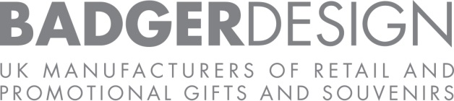

Statement of Policy
.
Date updated – 26/01/2026
Badger Design has a zero-tolerance attitude towards bribery. Even the suggestion of corruption may damage the reputation of the Company and affect its ability to do business, as well as the reputation of its employees and customers. Badger Design is therefore committed to doing business ethically, even if this means not gaining new business, not using the services of particular agents or business partners or incurring delays in carrying on our existing business.
Any violation of this Policy may result in disciplinary action, up to and including dismissal in appropriate circumstances.
The principles and obligations outlined in this Policy apply to all employees and directors.
Prohibition of Bribery
No person who is subject to this Policy shall:
- offer, provide, or authorise, a bribe or anything which may be viewed as a bribe either directly or indirectly or otherwise through any third party; or
- request or receive a bribe or anything which may be viewed as a bribe either directly or indirectly or otherwise through any third party, or perform their job functions improperly in anticipation, or in consequence, of a bribe.
- is not excessive in value or quantity, as defined by local procedural documents; and
- would not embarrass our Company if it was brought to public attention.

All persons who are subject to this Policy must remain vigilant and attempt to spot any of the scenarios listed below. If you should come across a potential issue of the kind listed below, you should (i) consider whether further investigation and due diligence of your counterparty is necessary; and/or (ii) escalate the matter to your manager and your Designated Legal/Compliance Officer.
Potential issues which call for further vigilance and/or investigation include:
- the prevalence of bribery in a country that has a nexus with the particular transaction or relationship (third party is located in such country or the transaction involves such country); e.g. according to the Corruption Perception Index (CPI) as evaluated annually by Transparency International
- payments of unusually high fees or commissions;
- requests for cash payments or requests for unexpected payments related to government approvals;
- requests for payments to different companies or through different countries;
- undefined or unreported payments to third parties made on Badger Design’s behalf
- no written agreements;
- unusually close relationships with government officials;
- a refusal to certify compliance with this Policy; or
- payments without a PO number, where applicable
As a company, we are committed to observing the laws and regulations which govern our operations in every country where we do business. This policy explains our. The man

