Beermats | 500 | 1000 | 2000 | 3000 | 5000 | 10,000 | 15,000 | 20,000 | 25,000 | 50,000 | 100,000
4 COLOUR PROCESS | £0.25 | £0.17 | £0.12 | £0.10 | £0.09 | £0.07 | £0.06 | £0.045 | £0.04 | £0.03 | £0.03
DELIVERY TO 1 UK MAINLAND ADDRESS | £13.50 | £13.50 | £13.50 | £17.00 | £20.50 | £27.50 | £45.00 | £70.00 | £70.00 | £140.00 | £140.00
DELIVERY TO ROI AND UK NON-MAINLAND | £26.50 | £26.50 | £26.50 | £45.00 | £56.50 | £76.60 | £110.00 | £220.00 | £220.00 | £220.00 | £220.00
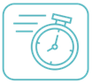
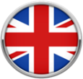
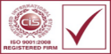
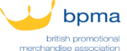
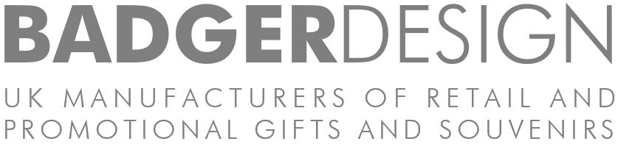
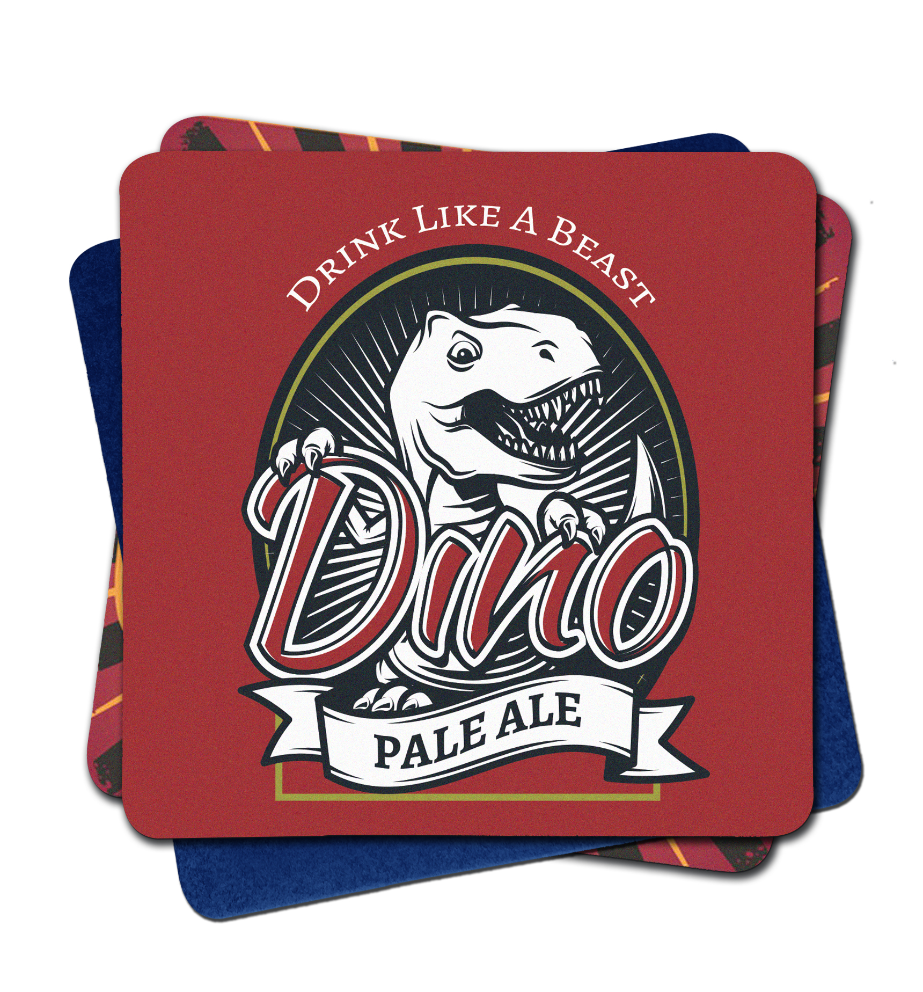
LEAD TIME: Normally 10-15 working days up to 1000 | 10-15 working days up to 10,000 | 15-20 working days up to 100000. These lead times may vary.
EXTRAS: Another interesting idea for promotional litho printed beermats is to add a printed QR code. This allows people to scan the code with their smartphone camera and this will take them straight to your website.
MAIN PRODUCT DETAILS
PRODUCT SIZE | 94mm diameter / 94mm square
PRINT AREA | Full Coverage
PACKED |
Packed in 125’s then 1000’s as standard
Commodity Code: 4705000000
Prices exclude VAT. Includes 1 origination. minimum quantity per design is 500.
Note they must be run in multiples of 500.
BADGER DESIGN LTD | EXETER AIRPORT BUSINESS PARK | DEVON | EX5 2UL

Litho printed beer mats are made from 100% recyclable wood pulp fibre board & eco inks, great for more complex designs or photographic images.
ADVANTAGES: made from 100% recyclable wood pulp fibre board. 1.2 mic (490gsm), Cost is the same for 1 or 2 sides.
PERFECT FOR: Bars, pubs, restaurants, casinos, hotels and drinks companies
PRICES
KEY NOTES
TRADE
BADGERDESIGN.COM | 01392 662100 | SALES@BADGERDESIGN.COM

We make them in the UK so that you get... TOP QUALITY | LOW PRICES | FAST DELIVERY

BADGERDESIGN.COM | 01392 662100 | SALES@BADGERDESIGN.COM

Litho Beermats – 94mm diameter / 94mm x 94mm

